**Image dithering**

Image dithering is a technique used in digital imaging to create the illusion of color depth in images with a limited color palette. It is especially useful when the display device or the image format supports only a few colors, but a richer, more detailed image is desired.

Procedure:

Step 1: Bring an image to dither in the photoshop, file-> open new.

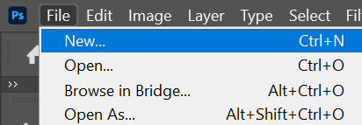

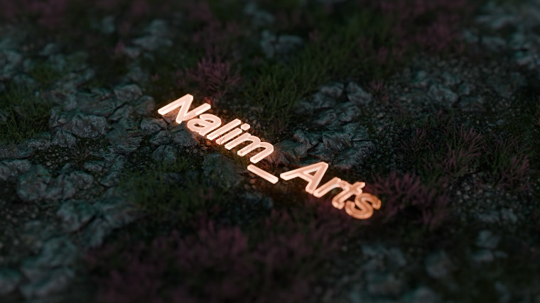

Step 2: Go to menu then Image -> mode-> Grayscale

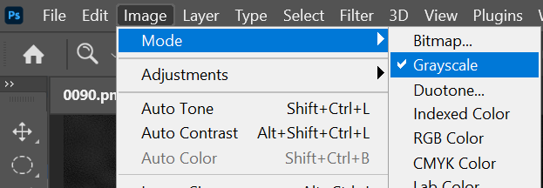

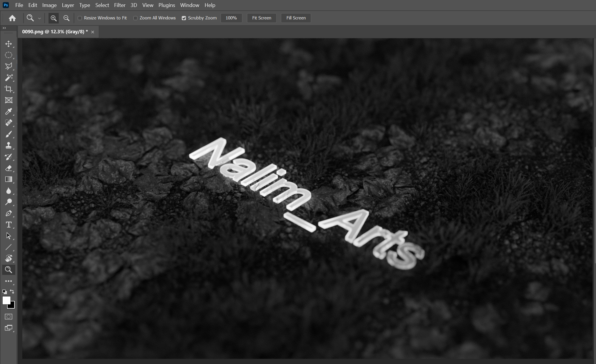

Step 3: Again go to menu -> mode -> bitmap.

Select pixel as per your need, and dither the image.

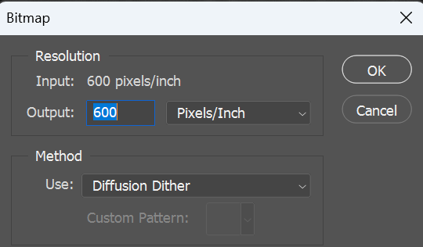

Final output:

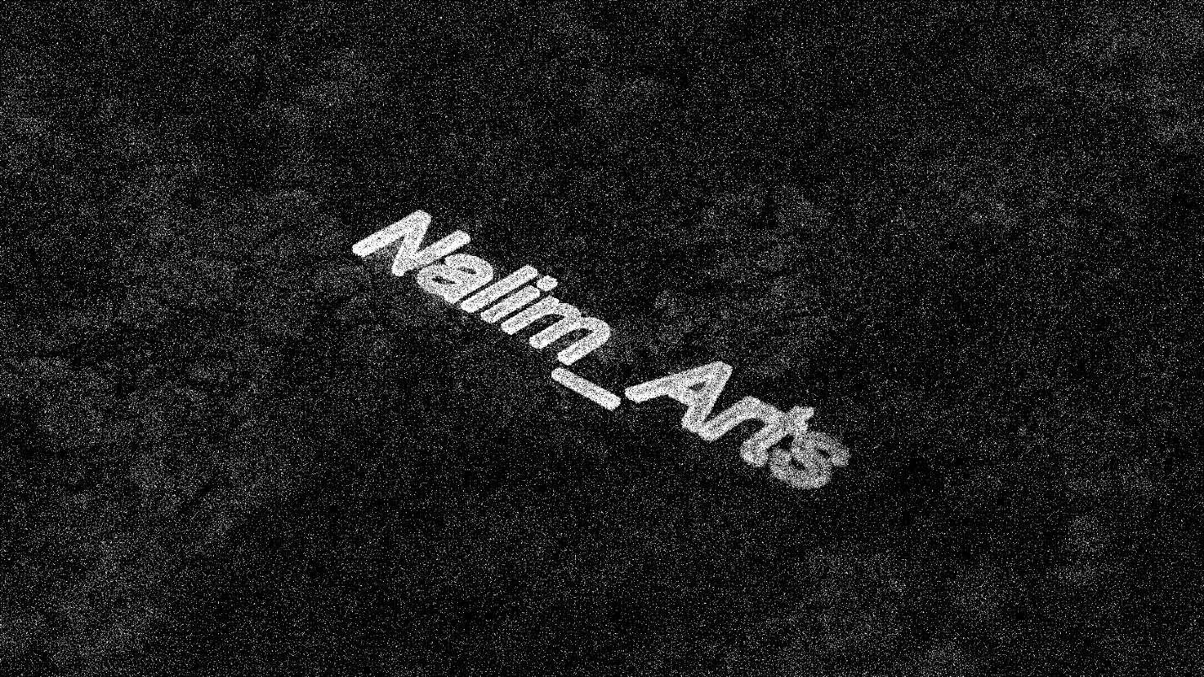

Conclusion:

Dithering significantly enhances the perceived visual quality of an image, even when the color palette is severely limited. By distributing the quantization error across neighboring pixels, the technique creates a smoother transition between colors, giving an impression of more shades and gradients than actually available.